# Terms and Conditions

# FRONT COVER:

## LEGAL NOTICE

The Publisher has strived to be as accurate and complete as possible in the creation of this report, notwithstanding the fact that he does not warrant or represent at any time that the contents within are accurate due to the rapidly changing nature of the Internet.

While all attempts have been made to verify information provided in this publication, the Publisher assumes no responsibility for errors, omissions, or contrary interpretation of the subject matter herein. Any perceived slights of specific persons, peoples, or organizations are unintentional.

In practical advice books, like anything else in life, there are no guarantees of income made. Readers are cautioned to reply on their own judgment about their individual circumstances to act accordingly.

This book is not intended for use as a source of legal, business, accounting or financial advice. All readers are advised to seek services of competent professionals in legal, business, accounting and finance fields.

You are encouraged to print this book for easy reading.

# Table Of Contents

Foreword

Chapter 1:

***Small Mammal Basics***

Chapter 2:

***Research What Type Of Small Mammal You Want***

Chapter 3:

***Determine Which Pet Will Best Fit With Your Family***

Chapter 4:

***Consider Other Pets In The House***

Chapter 5:

***Consider Your Budget And Resources***

Chapter 6:

***The Dangers Of Choosing The Wrong Small Mammal***

Wrapping Up

# Foreword

As with all animals, the decision to keep one as a pet, should only be done after due consideration is given to the thought process. Taking the time to gather a lot of knowledge on the subject and the availability of the supporting tools that would be needed for the comfort of the animal chosen should be the priority. Get all the info you need here.



***Multitudes Of Mammals***

Resources To Choose A Small Mammal As A Pet

# Chapter 1:

***Small Mammal Basics***

# Synopsis

Small mammals are highly dependent on the new owner to provide all the necessary assistance for its survival. However there are some exceptions to the sure but overall these small mammals need care and attention and any neglect would eventually cause their demise.



## The Basics

Some of these small mammals that would make ideal pet choices would include hamsters, guinea pigs, gerbils, rats, mice, rabbits and chinchillas. Some of these animals have comparatively short lifespan while others can live for longer periods, but all need the support, care and attention of the owner in order to have a happy and healthy life.

Some of these small mammals are nocturnal creatures and this would be quite frustrating as a pet for children. This would be because these small mammals would spend most of the day sleeping while the child would only be interested in playing with it. This could lead to a very stressful situation for the pet and the owner.

Also some of these pets are not really very active animals and even when awake they would rather just curl up comfortably beside the owner as opposed to running around and performing tricks. The owners who are more knowledgeable would probably understand the need for a quiet and cool location for the cage, thus they would make every effort to make sure this is done. Having other more active and boisterous pets around may not be the best thing for some of these rather sensitive mammals.

# Chapter 2:

***Research What Type Of Small Mammal You Want***

# Synopsis

When deciding on the particular type of small mammal to choose from as a pet, the potential owner would have to consider several different facts to ensure the right and most suitable choice is being made. This choice would depend on a variety of factors which either directly connect to the choice or indirectly does.

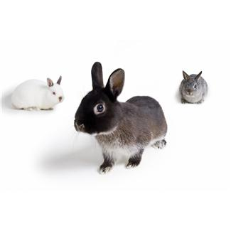

**What Type**

Small mammal pets usually cover a wide range of choices, such as mice, rabbits, gerbils, hamsters and guinea pigs. However even as small sized as they are, most of these pets can be really active and playful and would require a lot of attention and care. Aside from their furry cuteness, these small mammals are rather interesting and entertaining to watch. Most pet owners of small mammals will attest to simply being content with observing their pets for hours due to their often entertaining nature.

If the quest to acquire such a pet is a priority for the owner, then taking the time and effort to be as informed as possible about the particular small mammal chosen would be very beneficial to both parties. Failing which, the new pet would most likely suffer the consequences of poor care and thus eventually expire.

Elements to consider when conducting a research to find a suitable match as a pet would have to include matters such as the feasibility of acquiring the particular breed, the convenience of having it around permanently, the fit is makes into the current lifestyle of the individual, its food and housing needs, if the others pets will be able to adapt to the new comer, if the new pet will be able to adapt to its new environments and a whole host of other considerations, that should be taken into account before the small mammal is actually purchased.

**Chapter 3:**

***Determine Which Pet Will Best Fit With Your Family***

# Synopsis

Finding out a little about each small mammal beforehand will help the individual make a more informed choice as to the best pick for a pet, which will suit the family unit.

The following are some information on the different types of small mammals that would make ideal family pets:

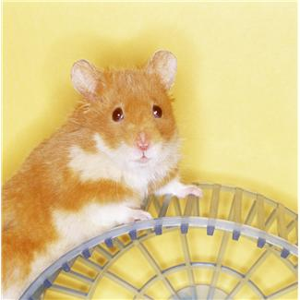

**What Will Fit**

Hamsters – the small mammals don’t really have a long life span and usually live up to about 2 – 3 years only. An adult hamsters would be about 6 inches in length and usually most comfortable as solitary items. Although they don’t really require large cages, because of their active nature a bigger cage would be better than a smaller one. Being sociable and having simple dietary requirements present this choice as a good one to pick.

Gerbils too have a short lifespan of about 2 – 3 years and are very sociable animals. This breed would be comfortable in pairs or even in small groups provided the living space provided is big enough to comfortable accommodate the number decided. However it should be noted that if they are to co- exist as a group, getting them together from a young age would be better than introducing an fully grown one into an already existing group. Keeping only males or females would be a good idea if the pet owner does not want to be burdened with a population explosion as these creature breed really fast.

This preview copy ends here and to get the full product, please go to (the website URL ).